

Consultants Specification Guide
Vigilon Plus Analogue Addressable System

Version: (1.1) 05/17

Contents

- VIGILON PLUS - FIRE ALARM CONTROL PANELS
1.1 VIGILON PLUS – FEATURES
1.2 VIGILON COMPACT PLUS AND VIGILON LOOP PARAMETERS
1.3 SYSTEM OVERVIEW
1.4 POWER SUPPLY & STANDBY BATTERIES
1.5 NETWORKING OF CONTROL PANELS
1.6 REPEAT PANELS
1.7 A3 MIMIC PANEL
1.8 LOOP DIAGNOSTICS AND SUPPORT TOOLS

- S-QUAD ANALOGUE SENSORS RANGE
2.1 HEAT SENSOR
2.2 HEAT SENSOR SOUNDER
2.3 HEAT SENSOR SOUNDER VISUAL ALARM & SPEECH
2.4 OPTICAL SENSOR
2.5 OPTICAL/HEAT SENSOR
2.6 OPTICAL/HEAT SENSOR SOUNDER
2.7 DUAL ANGLE OPTICAL/HEAT SENSOR
2.8 DUAL ANGLE OPTICAL/HEAT SENSOR SOUNDER
2.9 DUAL ANGLE OPTICAL/HEAT SPEECH
2.10 DUAL ANGLE OPTICAL/HEAT SENSOR WITH VISUAL ALARM DEVICE
2.11 DUAL ANGLE OPTICAL/HEAT SENSOR SOUNDER WITH SPEECH & VAD
  - DUAL ANGLE OPTICAL/HEAT SENSOR WITH CO
  - DUAL ANGLE OPTICAL/HEAT SENSOR WITH CO VISUAL ALARM AND SOUNDER SPEECH
- BEAM SENSORS
- DUCT SENSOR HOUSING
- S-QUAD BASES
- MANUAL CALL POINTS
- SOUNDERS
7.1 SYSTEM SOUNDER
7.2 LOW PROFILE SOUNDER
7.3 SYSTEM SOUNDER WITH INTEGRATED VISUAL ALARM DEVICE
(INCLUDING VOICE ENHANCED VARIANTS)
7.4 ENVIRONMENTAL PROTECTED SOUNDER WITH INTEGRATED VISUAL
ALARM DEVICE (INCLUDING VOICE ENHANCED VARIANTS)
- HAND HELD REMOTE CONTROL UNIT
- SOUNDER CONTROL
- INTERFACE UNITS
10.1 LOOP POWERED 4 CHANNEL INTERFACE UNIT
10.2 LOOP POWERED 1 CHANNEL INPUT UNIT/ZONE MODULE
10.3 LOOP POWERED 1 CHANNEL INPUT/OUTPUT INTERFACE UNIT
10.4 LOOP POWERED 1 CHANNEL OUTPUT INTERFACE MV
10.5 LOOP POWERED 1 CHANNEL INPUT/OUTPUT INTERFACE MV
10.6 LOOP POWERED 4 CHANNEL INPUT/OUTPUT INTERFACE MV
10.7 MAINS POWERED INTERFACE UNIT
10.8 LOOP POWERED SINGLE INPUT KEY OPERATED INTERFACE (NON FIRE)
10.9 LOOP POWERED 12 WAY NON FIRE INPUT UNIT
10.10 SERIAL INTERFACE WITH HONEYWELL VOICE ALARM
10.11 FAAST INTERFACE UNIT

- WINMAG GRAPHICS

- VIGILON PLUS - FIRE ALARM CONTROL PANELS

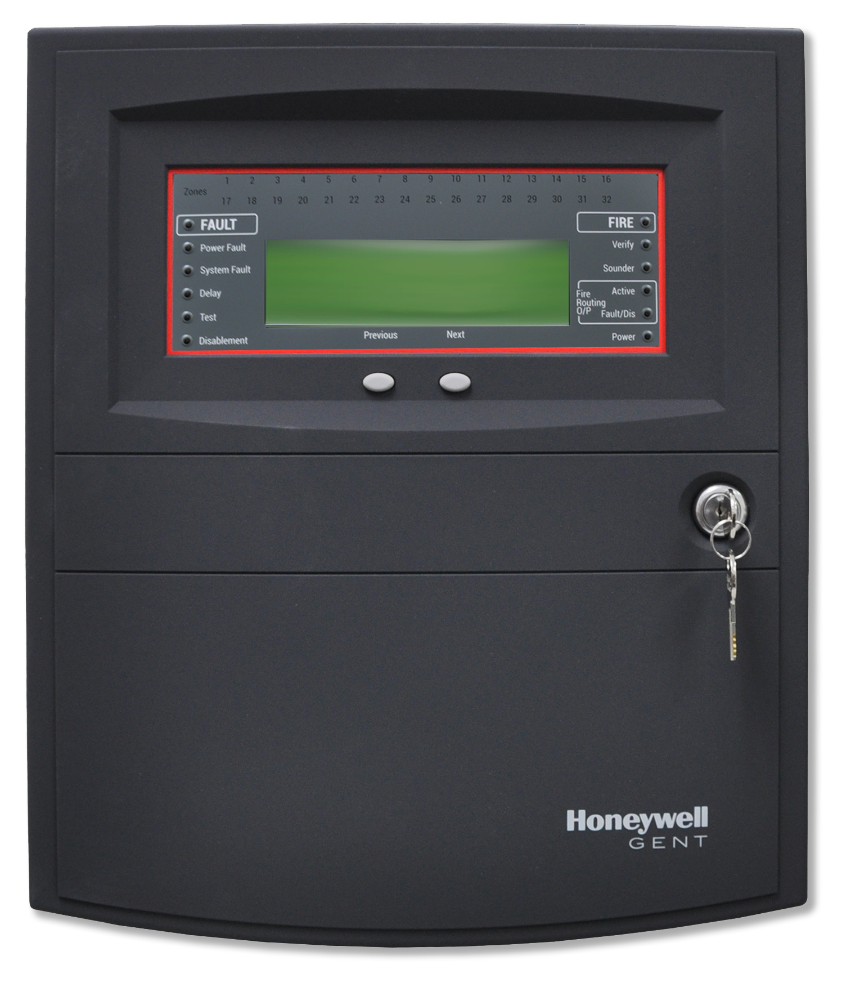 | 1 to 2 loop Vigilon Compact Plus Fire Alarm Control Panel  EN54 parts 2 & 4  Part Nos:  COMPACTPLUS-24 (1 loop Vigilon Compact Fire Alarm Control Panel c/w 1 loop card)  Compact LPC-EN (Additional Loop Card)  COMPACT-NC (Network Card)  PRINTER-HAND (Hand or Wall Mounted Printer)  COMPACT-FLUSH (Flush Surround)
Key features:

- 1 loop Control Panel
- Expandable to 2 loops
- Fully Networkable (to any EN54 Vigilon copper network) up to 31 Panels per domain (up to 200 panels on multi domain network)
- Remote Printer Option
- Internal keypad for programming with full QWERTY keyboard
- Surface or flush options
- Flash Memory Card to support commissioning and extended event log

Vigilon Compact Literature

Download CAD/BIM Symbols

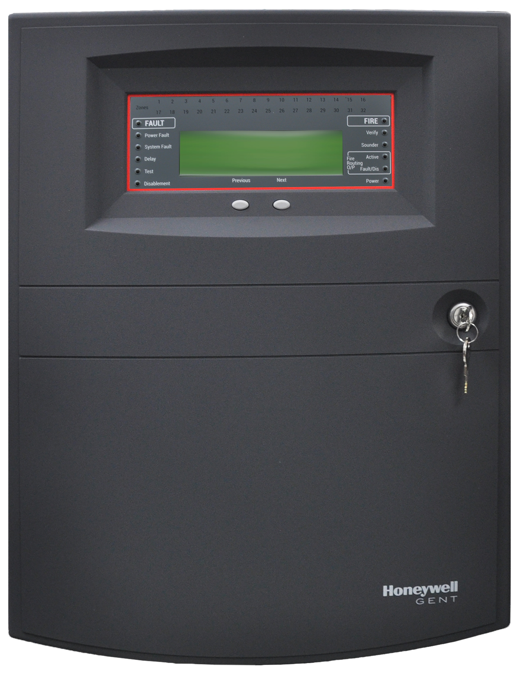 | 1 to 4 loop Vigilon Fire Alarm Control Panel  EN54 Parts 2 & 4  Part Nos:  VIGPLUS-24-NP (1 to 4 loop Vigilon Fire Alarm Control Panel c/w 1 loop card & no printer)  VIGPLUS -24 (1- 4 loop Vigilon Control Panel c/w 1 loop card & printer)  VIG-LPC-EN (Additional Loop Card)  VIG-NC (Network Card -Copper)  VIG-NC-FO (Network Card – Fibre)  VIG-IOC-DOM (input output card external communications)  VIG-24-Flush (Flush Surround)
Key features:

- 1 loop Control Panel
- Expandable to 4 loops
- Fully Networkable (BS & EN Networks) up to 31 Panels per domain (up to 200 panels on multi domain network)
- Integral Printer
- Internal keypad for programming with full QWERTY keyboard
- Surface or flush options
- Flash Memory Card to support commissioning and extended event log

Vigilon 1 - 4 Loop Literature
Download CAD/BIM Symbols

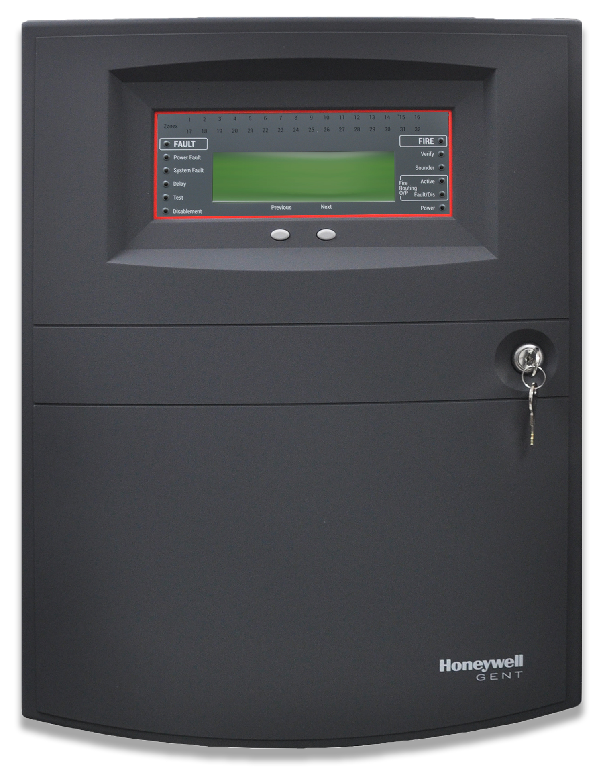 |  | 1 to 6 loop Vigilon Plus Fire Alarm Control Panel  EN54 Parts 2 & 4  Part Nos:  VIGPLUS-72 (1 - 6 loop Vigilon Control Panel c/w 1 loop card & printer)  Vig-LPC (Additional Loop Card)  VIG-24-FLUSH (Flush Surround)

Key features:

- 1 loop Control Panel
- Expandable to 6 loops
- Fully Networkable (BS & EN Networks) up to 31 Panels per domain (up to 200 panels on multi domain network)
- Integral Printer
- Internal keypad with full QWERTY keyboard for programming
- Surface or flush options
- 72 hour standby option
- Flash Memory Card to support commissioning and extended event log

Vigilon 1 - 6 Loop Literature

Download CAD/BIM Symbols

  - VIGILON PLUS – FEATURES
The Control and Indicating Equipment (CIE) shall provide visual indications for each of the following conditions:
- Power on
- Power fault
- Sounder fault
- Common fire
- Common fault
- System fault
- Verify
- Test
- Delay
- Disablement
- Fire Alarm Routing Activation

The CIE will be provided with the following as standard:

- Full “QWERTY” keyboard on all other Vigilon Plus Panels
- User Controls (start sounders, stop sounders, reset, cancel buzzer, verify)
- 4 soft keys for navigation of user functions (F1-4)
- 4 Custom user defined controls programmable for individual actions
- 2 x 400mA 24V monitored sounder circuits on VIG1-24/72, 250mA on Compact
- 2 x DPCO volt free programmable auxiliary contacts
- 1 x SPCO volt free manned centre link connection (MCL) labelled as Clean Contacts
- 1 x RS232/RS485 connection (additional card required on Vig1-24/72)
- 1 x RS 485 panel networking connection (network card required)
- 40 character x 8 line back-lit display text on green background
- 40 character thermal printer (Vig1– 24/72 versions only)
- 32 ‘secret until lit’ zonal indicators
- SAFE or SOFT addressing available
- 64 character length address label capability
- Co-incidence and multi-level fire detection
- Programmable delay for outputs (sounders and interfaces)
- Programmable timer to allow switching of sensor states
- 255 non fire programmable commands
- Automatic measurement of loop resistance during loop allocation and in service

1.2 VIGILON LOOP PARAMETERS

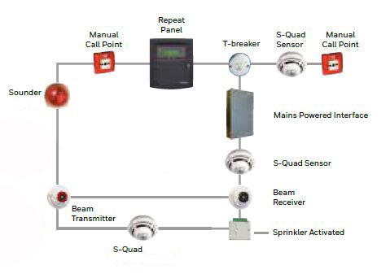 | Individual loop circuits will be capable of accommodating up to a maximum of the following:  - 2 km of approved fire rated cable (subject to audio/visual loading) and up to 2.5km with 2.5mm² cable  - 200 addressable devices per loop  - Up to 200 loop powered addressable sounders (including voice)  - Up to 100 loop power Visual Alarm devices  - 100 loop powered sensor sounders with integrated visual alarm (including voice)  - 125 sensors with integral sounder (including voice)  - 100 Sensor Sounder VADs (including voice)  - 16 loop powered beam sensor pairs (transmitter and receiver)  - 4 mimic and/or repeat indicator panels on any one detection loop.  - 8 mains powered interface units offering full BS7273-4 compliance  - 170 four channel loop powered interfaces (unless used as Conventional Zone then reduced to 32)  - 100 single channel input (unless used as Conventional Zone then reduced to 32)  - 170 single channel outputs

Vigilon System Overview Literature

1.3 SYSTEM OVERVIEW
The system will be analogue in operation, with each sensor device providing signal levels relative to the current operating environment. These analogue values will be transmitted to the control panel in a digital format to reduce possible corruption.

Outstation background environmental conditions will be monitored every 80 seconds to create a table of each analogue channel for event analysis. For sensors in a threshold condition 256 data readings will be taken, with fast-scanning employed to locate threshold outstations within a period of 0.5 seconds.

Addressing of any devices directly connected to the system will be carried out in a manner that does not require manual setting of switches in either, the device or its base i.e. all addressing will be carried out automatically by the control panel (soft addressed). Additionally the devices should be SAFE addressable (Software Addressed Firmware Encoded), where the address is retained in the device memory and the soft address encoded within each device. This will be achieved via control panel or commissioning software

To maintain system performance & compatibility, all equipment to be provided by one manufacturer, this manufacturer will be certified by the British Standards Institute under the registered company scheme to ISO 9001.

All field devices to be connected to the control panel are to be wired directly via 2 core loop circuits. Loop cable types to be selected in accordance with manufacturer’s recommendations to ensure optimum performance.

The system will be capable of providing fire, fault disablement and supervisory monitoring facilities as required by EN 54 Pt 2. Short or open circuit wiring fault isolation will be provided within every device to protect the system. “Group Circuit Monitors” which isolate/protect sections of a loop circuit, i.e. a group of field devices are not acceptable.
1.4 POWER SUPPLY & STANDBY BATTERIES

The system shall comprise of an integral EN54-4 certified charger and integral monitored sealed lead acid cells provided to maintain a standby period of 24 hours (minimum) with a further 30 minutes under full alarm load. Extended standby times up to 72 hrs is offered with the VIGPLUS-72 which has 2 sets of individually monitored sealed lead acid cells enclosed within a separate ventilated enclosure.
The batteries are to be maintenance free and the charger will be preset at a nominal DC output.

The charging current shall be automatically adjusted according to the batteries ambient temperature.
Should a full discharge of the cells take place, then the system will be capable of recharging within a 24hr period to be able to meet the whole standby .

If any form of malfunction is detected within the charger/cells unit then an appropriate fault message should be displayed. Individual messages will include:

- Mains supply lost
- Charger circuit failed
- Batteries 1-2 faulty
- Batteries 1-2 discharged
- Batteries 1-2 open circuit

1.5 NETWORKING OF CONTROL PANELS
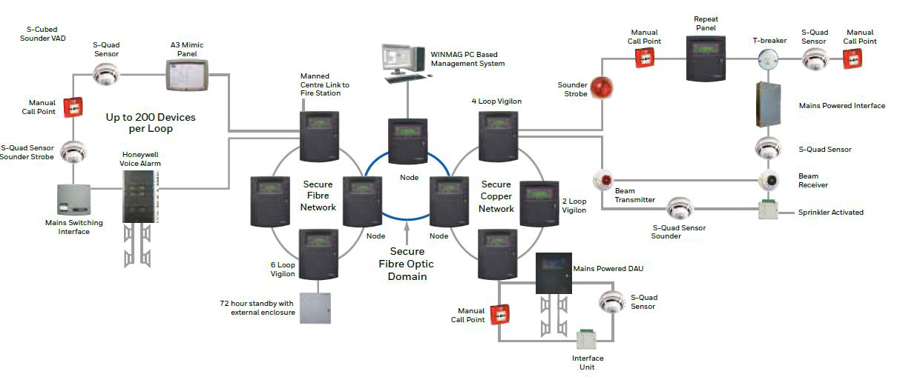 | Part Nos:  COMPACT-NC (Compact Network Card)  VIG-NC (Vigilon EN54 1-4 or 1-6 Loop Network Card)  VIG-NC-FO (Vigilon EN54 1-4 or 1-6 Fibre Optic Network Card)  VIG-NC-Dom-FO (Vigilon EN54 Fibre Optic Secure Domain Card)  VIG-NET-NODE (Vigilon Compact Network Node)  VIG-NODE-24 (Vigilon Network node)

All Panels are required to form a Secure Network wired in a ring to maintain integrity should a fault occur on the network cable. The wiring must be copper with any Networked Compacts but either Copper or Fibre on Vig1-24/72 only Networks.

An indication on one Panel should show on all Panels throughout the network or just on designated panels as required. Basic Fire Controls should be available to and from any designated panels on the Network.

Two networks of up to 31 panels can be brought together via a Domain Bridge, Terminal Nodes will be required to complete the Domain Bridge. Multiple domains allow up to 200 panels in a network.

1.6 REPEAT PANELS

Two Repeat Panel options are available:

- Fully Functional Repeat Panel (Loop Wired)
- Non functional Repeat Panel (RS485 link)

Loop Wired Fully Functional Repeater Panels

Loop Wired Fully Functional Repeater Panels

Part Nos:

VIGPLUS-RPT Vigilon Plus loop controlled repeat
VIG-RPT-FLUSH Flush Surround for Vigilon Repeat

Key Features:

- Fully Functional Repeat Panel with control
- Configurable for site-wide or local panel indication
- Connected to standard loop cabling to reduce installation costs
- 2 integral Line Isolators
- T-Breaker function for Connection to spur cabling
- 40 character by 8 line backlit LCD
- Local Power supply with 72hr backup supply as standard
The repeater panels will be similar in style, finish and essential user controls to that of Vigilon Fire Alarm Control Panel.

The panel will accept 230V AC supply @ 50Hz, and have an integral battery (12V) and charger. The battery provided will be capable of maintaining a standby period of 72 hours as well as additional 30 minutes with the system in alarm.

Should a full discharge of the cells take place, then the system shall be capable of re-charging the cells to support designed standby period within 24hr after power is restored.

All essential controls will be covered by a lockable hinged door, complete with a glass/clear perspex window to enable the display to be read at all times.

Other control features available to the user via the repeater panel shall include:

i) CONTROL MENU - to allow for disablements of alarm sectors, sensors and interface I/O lines.
ii) INFORMATION MENU - to provide fire, fault, warning and supervisory events.

This enables the repeat panel to be used for the day to day operation of the system.
Any malfunction of the repeat panel will be displayed both locally and at the main control panel. If the system for whatever reason is not communicating with repeat panels the repeater will display “MAIN PANEL OFF LINE”.

Vigilon Fully Functional Repeater Panel Literature
Download CAD/BIM Symbols

Non-Functional Repeat Panel

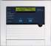 | Non-Functional Repeat Panel  Part Nos:  Compact-Rpt (Vigilon EN54 LCD Non Functional Repeater Panel)  VIG-IOC-DOM Serial IO card Vigilon

Up to 4 Non Functional Repeater Panels can be linked from any Vigilon Fire Alarm Control Panel
Non Functional Repeater Panels are wired as a linked radial circuit from the Vigilon Fire Alarm Control Panel (daisy chained).

When used with Vigilon Compact only, the first Repeater can be powered from the Vigilon Control Panel, additional Non Functional Repeaters require a local PSU. On Vigilon, all Repeaters require a PSU.

Vigilon Non Functional Repeater Literature
  - A3 MIMIC PANEL
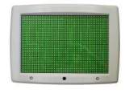 | Mimic Panel  Part Nos:  Vig-Mim-A3 (A3 Mimic Panel wired on loop & requiring 230v Mains Supply)  S4-34600 (LED driver board)  S4-34494 (Connection converter, ribbon to terminal block)

The mimic panel will be similar in style and finish to the control panel and be available in A3 sized format. It will be sighted in a conspicuous and well-lit area, preferably the entrance where the fire-fighting team will arrive.

This provides pin-point accuracy in determining the location of a Fire, Fault or Supervisory event by Device, Zone, Non Fire Command, Loop or Panel and the flexibility to tailor to Customers requirements.
The panel will be a standard unit with all site specific information being programmed “on site”, this information will be uploaded through an onboard USB port and held in E² memory, which may be modified at a later date to encompass any site changes. The panel shall have a button to Silence the Alarm Buzzer and perform an LED test at access level 1.

The panel will accept the 230V AC supply @ 50Hz, and have an integral battery (12V) and charger. The battery provided will be capable of maintaining a standby period of 72 hours (minimum) with a further 30 minutes, under full alarm/control load conditions.

Should a full discharge of the cells take place, then the system shall be capable of completely re-charging the cell within a 24hr period.

The mimic panels shall be connected on the same 2-wire loop as the sensors and sounders. Also within the panel, terminals will be provided to allow a loop spur connection to be made as standard.
A drawing of the area covered by the system shall locate between the front cover and overlaying an array of 1536 hi-brightness LEDs.

The following options will be required as standard:

- Optional clock display in the form. (HH:MM)
- Optional Fire message display
- A full range of alphanumeric characters both upper and lower case.
- Steady or flashing illumination, being either in phase or anti-phase.
- First fire flashing option.
- 128 Zone display as standard.
- Custom default display message
- Roaming LED Working Indicator
The Electrical Contractor shall provide a site outline diagram to allow the Fire Specialist Company to produce an overlay drawing for the mimic panels.

It shall be possible to provide a customised mimic panel using the addition of LED driver boards for up to 768 LED outputs.

A3 Mimic Literature

Download CAD/BIM Symbols

1.8 SYSTEM SUPPORT TOOLS

1.8.1 VIGINSITE System Information & Management Tool

The System shall support the connection of VigInSite Tool to access information and support installed systems. Access to the different features will be licence controlled to allow access only to authorised engineers.

The VigInSite Tool shall offer access to the following information

- Download of detailed logs showing active and historic events
- Summary of connected devices showing device age and health
- .Network and Loop Maps
- Device and panel firmware versions

In addition the VigInSite tool shall offer the following engineer support function

- Find outstation feature
- Record of Test Fire activity
- Firmware upgrade of Loop and control software
- Cause and Effect simulation confirming activation of sectors and command build events across the whole network
- Access to extended event log held on control card flash memory card

1.8.2 LOOP DIAGNOSTICS

The system loop card shall provide measurement of the loop resistance during allocation and during maintenance.

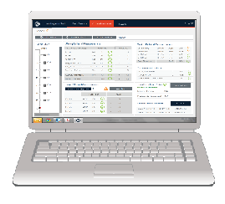 | Part Nos:  LDT-UK-I (Loop Diagnostic Tool UK&I)

The panel will have the capability to connect to loop diagnostics software allowing engineers to fully verify integrity of the loop cabling. The diagnostics tool will be used to test the loop integrity during commissioning and as part of the annual service and have the ability to generate a report to support the commissioning documentation.

In particular the tool shall be capable of:

- Measuring Overall Loop resistance and capacitance
- Compare actual resistance with predicted values
- Perform loop checks while under full alarm load
- Communications timings with loop devices
- Identify and locate loop earth faults and provide Customer & engineer cable certificates
- S-QUAD ANALOGUE SENSORS RANGE

The following types of analogue sensors will be available as standard: |  | 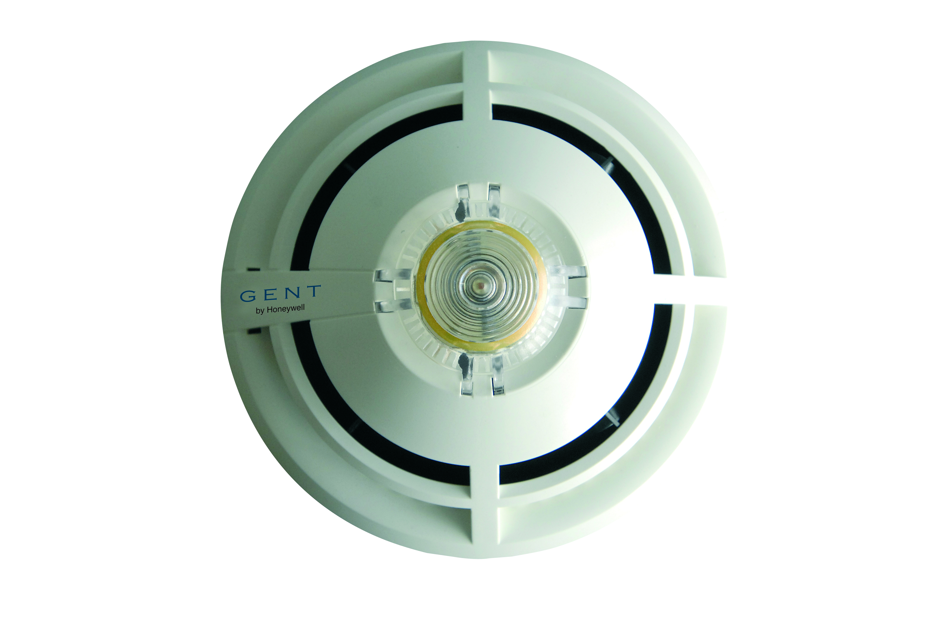
Heat Sensors
Heat Sensor |  | S4-720
Heat Sensor Sounder |  | S4-780
Heat Sensor with VAD (Red & White) |  | S4-720-V-VAD-HPR  S4-720-V-VAD-HPW
Optical Sensors options
Optical Sensor |  | S4-715
Optical Heat Sensor |  | S4-710
Optical Heat Sensor Sounder |  | S4-770-S
Dual Optical Heat Sensors
Dual Optical Heat Sensor (white body) |  | S4-711
Dual Optical Heat Sensor (black body) |  | S4BK-711
Dual Optical Heat Sensor Sounder |  | S4-771
Dual Optical Heat Sensor Speech (white body) |  | S4-711-V
Dual Optical Heat Sensor Speech (black body) |  | S4BK-711-V
Dual Optical Heat Sensor VAD (Red and White) |  | S4-711-VAD-HPR  S4-711-VAD-HPW
Dual Optical Heat Sensor Sounder with speech and VAD (Red and White) |  | S4-711-VAD-HPR  S4-711-VAD-HPW
CO Sensors
Dual Optical Heat CO Sensor |  | S4-901
Dual Optical Heat CO Sensor sounder with speech and Red and White VAD (white body) |  | S4-911-V-VAD-HPR  S4-911-V-VAD-HPW
Dual Optical Heat Sensor Sounder with speech and Red and White VAD (black body) |  | S4BK-711-V-VAD-HPR
Accessories
S Quad Sensor Base |  | S4-700
IP 21 gasket for S-Quad Base |  | S4-701
IP 21 gasket for S-Quad Base (pack of 5) |  | S4-705
S Quad Remote LED |  | 13449-01
Duct Housing (including base and 0.6M tube) |  | S4-34760

2.1 HEAT SENSOR

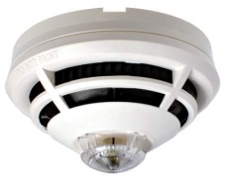 | EN 54 Parts 5, 17 & 18  Part Nos:  S4-720 (Heat Sensor)  S4-700 (Base)

Key Features:

- 200 per loop
- Rate of rise and fixed temperature sensing
- 6 configurable sensing states (Class A1, A2, A2S, B and BS)
- 2 integral Line Isolators
- Configurable monitored input output

Heat Sensing:

Will be carried out by a thermistor, sampling the surrounding environmental temperature.
Each sensor will possess an integral red LED giving a flashing indication for a fire signal or a continuous indication for certain fault indications. Optional setting for LED to flash to confirm loop connectivity communications.

Link to - Heat Sensor Literature

2.2 HEAT SENSOR SOUNDER
EN 54 Parts 3, 5, 17 & 18

Part Nos:
S4-780-S (Heat Sensor Sounder)
S4-700 (Base)

Key Features:

- 200 per loop
- Rate of rise and fixed temperature sensing
- 6 configurable Sensing States (Class A1, A2, A2S, B and BS)
- Integral Sounder (85dbA typical, +3dbA in turbo mode)
- 2 integral Line Isolators
- Active Sounder circuit monitoring
- Configurable monitored input output

Heat Sensing:

Will be carried out by a thermistor, sampling the surrounding environmental temperature.

Sounder:

Integral Sounders will be capable of providing up to 3 different sound signals, which are selected/configured via the main control panel. Individual sensor sounder volume levels shall be adjustable via the use of a laptop PC and appropriate programming software from the manufacturer.

The frequency of sound signals emitted will be as follows:

- 910Hz Low Sound
- 970Hz High Sound
In order to meet with the requirements of BS5839 Part 1.
Activation of the sounder shall be independent of the detection of a fire condition by the sensing element.

Each sounder will have its own microprocessor to handle loop communications, which along with all other associated electronic components will be sealed.

Each sensor will possess an integral red LED giving a flashing indication for a fire signal or a continuous indication for certain fault indications. Optional setting for LED to flash to confirm loop connectivity communications.

It shall be possible to disable the heat sensor functionality independently from the sounder.

Heat Sensor Sounder Literature
Download CAD/BIM Symbols
Download Gent’s S-Quad Selector App for iOS and Android

2.3 HEAT SENSOR SOUNDER WITH SPEECH & VISUAL ALARM

EN 54 Parts 3, 5, 17, 18 & 23

Part Nos:

S4-720-V-VAD-HPW Heat Sensor c/w speech sounder & Visual Alarm (White)
S4-720-V-VAD-HPR Heat Sensor c/w speech sounder, & Visual Alarm (Red)
S4-700 (Base)
S4-701 IP21 Gasket (S4-705 Pack of 5)

Key Features:

- 60 per loop as Sounder, 40 per loop as Speech
- Rate of rise and fixed temperature sensing
- 6 selectable EN54 sensing states (Class A1, A2, A2S, B and BS)
- Integral Sounder (85dbA typical, +3dbA in turbo mode)
- 3 Emergency Speech Messages as standard
- 1 Bell Tone
- 2 integral Line Isolators
- Active Sounder and VAD circuit monitoring
- Configurable monitored input output
- Integrated EN54 part 23 visual alarm device

Heat Sensing:

Will be carried out by a thermistor, sampling the surrounding environmental temperature.

Visual Alarm Device

The integral VAD element shall utilise a high power red or white LEDs with variable intensity settings. LED pulsing shall be synchronised with all other loop powered audible visual units located on the fire alarm and detection system with the option to programme changes to the pulse timings (ranging from 1, 2 or 4 seconds). The VAD circuit shall be actively monitored for working operation.
Activation of the VAD shall be independent of the detection of a fire condition by the sensing element.

Speech:
The speech function shall be provided by stored messages on an internal flash memory. Output from the flash memory processor shall be 20 seconds of speech. Additionally there shall be the capability to provide complex tones, such as bell tones. Each sensor shall include 4 standard messages within the flash memory.
As standard, the device flash memory shall contain the following messages:

Alert Message: (Female Voice) | “An incident has been reported in the building, please await further instructions”
Alarm Message 1: (Female Voice) | “Attention please, this is an emergency please leave the building by the nearest available exit”
Alarm Message 2: (Male Voice) | “This is a Fire Alarm! Please leave the building immediately by the nearest available exit”
Test Message: (Female Voice) | “This is a test message, no action is required”

It shall be possible to have bespoke site specific message and tone options recorded and installed.
A test of the message storage device, amplifier, power supply and tone generator 'piezo' within the sounder shall be carried out by the fire alarm control panel daily. Should the sounder fail to produce the required tone quality of sound output, then a fault indication shall be provided at the control panel. Sounders shall be capable of being tested for the conditions described above in both the quiescent and alarm state. The sounder shall be able to perform a resonance search to optimise the frequency to ensure minimum current draw in alarm.

Bell Tone:

In addition to the voice messages above, an 8 Inch solenoid bell recording shall be provided as a standard complex tone.

All speech outputs shall be synchronised with all other loop powered sensor speech devices and other loop powered audible visual units on the panel.
Each sensor will possess an integral red LED giving a flashing indication for a fire signal or a continuous indication for certain fault indications. Optional setting for LED to flash to confirm loop connectivity communications.
Heat Sensor Sounder Speech VAD Literature
Download CAD/BIM Symbols
Download Gent’s EN54-23 Explainer Video
Download Gent’s S-Quad Selector App for iOS and Android

2.4 OPTICAL SENSOR
EN 54 Parts 7, 17 & 18

Part Nos:
S4-715 (Optical Smoke Sensor)
S4-700 (Base)

Key Features:

- 200 per loop
- Optical Sensor
- Three selectable EN54 sensing states with combinations of optical smoke and false alarm filtering
- Two integral Line Isolators
- Configurable monitored input output
Optical Sensing:

Will be carried out by means of an Infra-red LED transmitting a pulse of light across an obtuse angled chamber.
Each sensor will possess an integral red LED giving a flashing indication for a fire signal or a continuous indication for certain fault indications. Optional setting for LED to flash to confirm loop connectivity communications.

Optical Sensor Literature
Download CAD/BIM Symbols
Download Gent’s S-Quad Selector App for iOS and Android

2.5 OPTICAL/HEAT SENSOR
EN 54 Parts 5, 7, 17 & 18

Part Nos:
S4-710 (Optical Heat Sensor)
S4-700 (Base)

Key Features:

- 200 per loop
- Optical & Heat Sensor
- Sensing elements fully programmable to meet risk11 Sensing States 5 selectable EN54 Sensing States with combinations of Optical smoke and Class A1, A2, A2S, B and BS heat sensing
- Two integral Line Isolators
- Configurable monitored input output
Optical Sensing:

Will be carried out by means of an Infra-red LED transmitting a pulse of light across an obtuse angled chamber.
Heat Sensing:

Will be carried out by a thermistor, sampling the surrounding environmental temperature.
Each sensor will possess an integral red LED giving a flashing indication for a fire signal or a continuous indication for certain fault indications. Optional setting for LED to flash to confirm loop connectivity communications.

Optical Hear Sensor Literature

2.6 OPTICAL/HEAT SENSOR SOUNDER

EN 54 Parts 3, 5, 7, 17 & 18

Part Nos:

S4-770-S (Optical Heat Sensor)
S4-700 (Base)
Key Features:

- 200 per loop
- Optical & Heat Sensor
- Sensing elements fully programmable to meet risk
- 11 sensing states five selectable EN54 sensing states with combinations of optical smoke and Class A1, A2, A2S, B and BS heat sensing
- Integral Sounder (85dbA typical, +3dbA in turbo mode)
- 2 integral Line Isolators
- Configurable input output

Optical Sensing:

Will be carried out by means of an Infra-red LED transmitting a pulse of light across an obtuse angled chamber.

Heat Sensing:

Will be carried out by a thermistor, sampling the surrounding environmental temperature.
Sounder:

Integral Sounders will be capable of providing up to 3 different sound signals, which are selected/configured via the main control panel. Individual sensor sounder volume levels shall be adjustable via the use of a laptop PC and appropriate programming software from the manufacturer.
The frequency of sound signals emitted will be as follows:

- 910Hz Low Sound
- 970Hz High Sound
In order to meet with the requirements of BS5839 Part 1, The sounder shall be able to perform a resonance search to optimise the frequency to ensure minimum current draw in alarm. Activation of the sounder shall be independent of the detection of a fire condition by the sensing element.
Each sounder will have its own microprocessor to handle loop communications, which along with all other associated electronic components and will be sealed.

Each sensor will possess an integral red LED giving a flashing indication for a fire signal or a continuous indication for certain fault indications. Optional setting for LED to flash to confirm loop connectivity communications.

The sounder functionality shall be automatically actively monitored daily and indicate a fault in the case of malfunction.

Optical Heat Sensor Sounder Literature
Download CAD/BIM Symbols
Download Gent’s S-Quad Selector App for iOS and Android

2.7 DUAL ANGLE OPTICAL/HEAT SENSOR
EN 54 Part 5, 7, 17 & 18

Part Nos:

S4-711 (Dual Optical Heat Sensor)
S4-700 (Base)
S4BK-700 (Dual Optical Heat Sensor (black))
S4BK-711 (Base in black)

Key Features:

- 200 per loop
- Dual Optical & Heat Sensor
- Sensing elements fully programmable to meet risk
- 10 selectable EN54 sensing states with combinations of optical smoke and Class A1, A2, A2S, B and BS heat sensing
- 2 integral Line Isolators
- Configurable input output
- Available in both White (RAL9010) and Black (RAL9005)

This device will combine three individual sensing elements to provide excellent cover for multiple types of fires (Slow smouldering and fast free burning).
Optical Sensing:

Sensing will be carried out by 2 infra-red LED transmitters using separate optical detection angles. This sensor shall process both the reflection and light absorption properties of particles entering the detection chamber of the device, allowing the detection system to differentiate between smoke and steam particles.

Heat Sensing:

Will be carried out by a thermistor, sampling the surrounding environmental temperature.
Each sensor will possess an integral red LED giving a flashing indication for a fire signal or a continuous indication for certain fault indications. Optional setting for LED to flash to confirm loop connectivity communications.

Dual Optical Hear Sensor Literature

Download CAD/BIM Symbols

Download Gent’s S-Quad Selector App for iOS and Android

2.8 DUAL ANGLE OPTICAL/HEAT SENSOR SOUNDER

EN 54 Part 3, 5, 7, 17 & 18

Part Nos:

S4-771–S (Dual Optical Heat Sensor c/w Sounder)
S4-700 (Base)

Key Features:

- 200 per loop
- Dual Optical & Heat Sensor
- Sensing elements fully programmable to meet risk
- 10 selectable EN54 Sensing States with combinations of Optical smoke and Class A1, A2, A2S, B and BS heat sensing
- Integral Sounder (85dbA typical, +3dbA in turbo mode)
- 10 selectable EN54 sensing states with combinations of optical smoke and Class A1, A2, A2S, B and BS heat sensing
- 2 integral Line Isolators
- Configurable input output

This device will combine three individual sensing elements to provide excellent cover for multiple types of fires (Slow smouldering and fast free burning).
Optical Sensing:

Sensing will be carried out by 2 infra-red LED transmitters using separate optical detection angles. This sensor shall process both the reflection and light absorption properties of particles entering the detection chamber of the device, allowing the detection system to differentiate between smoke and steam particles.

Heat Sensing:

Will be carried out by a thermistor, sampling the surrounding environmental temperature.
Sounder:

Integral Sounders will be capable of providing up to 3 different sound signals, which are selected/configured via the main control panel. Individual sensor sounder volume levels shall be adjustable via the use of a laptop PC and appropriate programming software from the manufacturer.

The frequency of sound signals emitted will be as follows:

- 910Hz Low Sound
- 970Hz High Sound

In order to meet with the requirements of BS5839 Part 1.Activation of the sounder shall be independent of the detection of a fire condition by the sensing element. Each sounder will have its own microprocessor to handle loop communications, which along with all other associated electronic components will be sealed.

Each sensor will possess an integral red LED giving a flashing indication for a fire signal or a continuous indication for certain fault indications. Optional setting for LED to flash to confirm loop connectivity communications.

The sounder functionality shall be automatically actively monitored daily and indicate a fault in the case of malfunction.

The sounder shall be able to perform a resonance search to optimise the frequency to ensure minimum current draw in alarm.

Dual Optical Heat Sensor Sounder Literature
Download CAD/BIM Symbols
Download Gent’s S-Quad Selector App for iOS and Android

2.9 DUAL ANGLE OPTICAL/HEAT SPEECH

EN 54 Parts 5, 7, 17 & 18

Part Nos:

S4-711-V (Dual Optical Heat Sensor c/w Speech) White Body
S4BK-711-V (Dual Optical Heat Sensor c/w Speech) Black Body S4-700 (Base)
S4-700 (Base - White )
S4BK-700 (Base – Black

Key Features:

- 200 per loop
- Dual Optical & Heat Sensor
- Sensing elements fully programmable to meet risk
- 10 selectable EN54 sensing states with combinations of optical smoke and Class A1, A2, A2S, B and BS heat sensing
- Integral Sounder (85dbA typical, +3dbA in turbo mode)
- 10 selectable EN54 Sensing States with combinations of optical smoke and Class A1, A2, A2S, B and BS heat sensing
- Two integral Line Isolators
- Configurable input output
- Three Emergency Speech Messages as standard
- One Bell Tone

This device will combine three individual sensing elements to provide excellent cover for multiple types of fire (Slow smouldering and fast free burning).
Optical Sensing:

Sensing will be carried out by 2 infra-red LED transmitters using separate optical detection angles. This sensor shall process both the reflection and light absorption properties of particles entering the detection chamber of the device, allowing the detection system to differentiate between smoke and steam particles.

Heat Sensing:

Will be carried out by a thermistor, sampling the surrounding environmental temperature.

Speech:
The speech function shall be provided by stored messages on an internal flash memory. Output from the flash memory processor shall be 20 seconds of speech. Additionally there shall be the capability to provide complex tones, such as bell tones. Each sensor shall include 4 standard messages within the flash memory.
As standard, the device flash memory shall contain the following messages:

Alert Message: (Female Voice) | “An incident has been reported in the building, please await further instructions”
Alarm Message 1: (Female Voice) | “Attention please, this is an emergency please leave the building by the nearest available exit”
Alarm Message 2: (Male Voice) | “This is a Fire Alarm! Please leave the building immediately by the nearest available exit”
Test Message: (Female Voice) | “This is a test message, no action is required”
It shall be possible to have bespoke site specific message and tone options recorded and installed.
A test of the message storage device, amplifier, power supply and tone generator 'piezo' within the voice enhanced sounder shall be carried out by the fire alarm control panel daily. Should the sounder fail to produce the required tone quality of sound output, then a fault indication shall be provided at the control panel. Sounders shall be capable of being tested for the conditions described above in both the quiescent and alarm state.

Bell Tone:

In addition to the voice messages above, an 8 Inch solenoid bell recording shall be provided as a standard complex tone.

All speech outputs shall be synchronised with all other loop powered sensor speech devices and other loop powered audible visual units on the panel.
Each sensor will possess an integral red LED giving a flashing indication for a fire signal or a continuous indication for certain fault indications. Optional setting for LED to flash to confirm loop connectivity communications.

Dual Optical Heat Sensor Speech Literature

Download CAD/BIM Symbols
Download Gent’s S-Quad Selector App for iOS and Android

2.10 DUAL ANGLE OPTICAL/HEAT SENSOR WITH INTEGRATED VISUAL ALARM DEVICE
EN 54 Parts 5, 7, 17 & 18

Part Nos:

S4-711-VAD-HPR (Dual Optical Heat Sensor c/w Visual Alarm (Red))
S4-711-VAD-HPW (Dual Optical Heat Sensor c/w Visual Alarm (White))
S4-700 (Base)
S4-701 (IP21 Gasket) (S4-705 Pack of 5)

Key Features:
- Up to 100 per loop depending intensity setting
- Dual Optical & Heat Sensor
- Sensing elements fully programmable to meet risk
- 10 selectable EN54 sensing states with combinations of optical smoke and Class A1, A2, A2S, B and BS heat sensing
- Integrated EN54 part 23 visual alarm device
- 10 selectable EN54 Sensing States with combinations of optical smoke and Class A1, A2, A2S, B and BS heat sensing
- Two integral Line Isolators
- Configurable input output

This device will combine two individual sensing elements to provide excellent cover for multiple types of fires (Slow smouldering and fast free burning).
Optical Sensing:
Sensing will be carried out by 2 infra-red LED transmitters using separate optical detection angles. This sensor shall process both the reflection and light absorption properties of particles entering the detection chamber of the device, allowing the detection system to differentiate between smoke and steam particles.

Heat Sensing:

Will be carried out by a thermistor, sampling the surrounding environmental temperature.
Visual Alarm Device

The integral VAD element shall utilise a high power red or white LEDs with variable intensity settings. LED pulsing shall be synchronised with all other loop powered audible visual units located on the fire alarm and detection system with the option to programme changes to the pulse timings (ranging from 1, 2 or 4 seconds). The VAD circuit shall be actively monitored for working operation.
Activation of the VAD shall be independent of the detection of a fire condition by the sensing element.
Each sensor will possess an integral red LED giving a flashing indication for a fire signal or a continuous indication for certain fault indications. Optional setting for LED to flash to confirm loop connectivity communications.

Dual Optical Heat Sensor VAD Literature
Download CAD/BIM Symbols
Download Gent’s EN54-23 Explainer Video
Download Gent’s VAD Tool for iPad
2.11 DUAL ANGLE OPTICAL/HEAT SENSOR SOUNDER VISUAL ALARM WITH SOUNDER & SPEECH

EN 54 Parts 3, 5, 7, 17, 18 & 23

Part Nos:

S4-711-V-VAD-HPR (Dual Optical Heat Sensor c/w Speech Sounder and VAD (Red))
S4-711-V-VAD-HPW (Dual Optical Heat Sensor c/w Speech Sounder and VAD (White))
S4BK-711-V-VAD-HPR (Dual Optical Heat Voice Sensor c/w speech sounder and red VAD (black body))
S4BK-700 (Base in black)
S4-700 (Base)
S4-701 (IP21 Gasket) (S4-705 Pack of 5)

Key Features:

- Up to 100 per loop depending intensity setting
- Dual Optical & Heat Sensor
- Sensing elements fully programmable to meet risk
- Integrated EN54 part 23 visual alarm device
- 10 selectable EN54 sensing states with combinations of optical smoke and Class A1, A2, A2S, B and BS heat sensing
- Two integral Line Isolators
- Configurable input output
- Available in both White (RAL9010) and Black (RAL9005)

This device will combine two individual sensing elements to provide excellent cover for multiple types of fires (Slow smouldering and fast free burning).

Optical Sensing:

Sensing will be carried out by 2 infra-red LED transmitters using separate optical detection angles. This sensor shall process both the reflection and light absorption properties of particles entering the detection chamber of the device, allowing the detection system to differentiate between smoke and steam particles.
Heat Sensing:

Will be carried out by a thermistor, sampling the surrounding environmental temperature.

Sounder:

Integral Sounders will be capable of providing up to 3 different sound signals, which are selected/configured via the main control panel. Individual sensor sounder volume levels shall be adjustable via the use of a laptop PC and appropriate programming software from the manufacturer.
The frequency of sound signals emitted will be as follows:
- 910Hz Low Sound
- 970Hz High Sound
In order to meet with the requirements of BS5839 Part 1.
Activation of the sounder shall be independent of the detection of a fire condition by the sensing element. The device shall also incorporate and activate a self test low volume audible sequence. It shall be possible to disable this sequence at the main control panel.
Each sounder will have its own microprocessor to handle loop communications, which along with all other associated electronic components will be sealed.

EN54- 23 Visual Alarm Device

The integral VAD element shall utilise a high power red or white LEDs with variable intensity settings. LED pulsing shall be synchronised with all other loop powered audible visual units located on the fire alarm and detection system with the option to programme changes to the pulse timings (ranging from 1, 2 or 4 seconds). The VAD circuit shall be actively monitored for working operation.
Activation of the VAD shall be independent of the detection of a fire condition by the sensing element.

Speech:
The speech function shall be provided by stored messages on an internal flash memory. Output from the flash memory processor shall be 20 seconds of speech. Additionally there shall be the capability to provide complex tones, such as bell tones. Each sensor shall include 4 standard messages within the flash memory.
As standard, the flash memory shall contain the following messages:

Alert Message: (Female Voice) | “An incident has been reported in the building, please await further instructions”
Alarm Message 1: (Female Voice) | “Attention please, this is an emergency please leave the building by the nearest available exit”
Alarm Message 2: (Male Voice) | “This is a Fire Alarm! Please leave the building immediately by the nearest available exit”
Test Message: (Female Voice) | “This is a test message, no action is required”

It shall be possible to have bespoke site specific message and tone options recorded and installed.
A test of the message storage device, amplifier, power supply and tone generator 'piezo' within the voice enhanced sounder shall be carried out by the fire alarm control panel once an hour. Should the sounder fail to produce the required tone quality of sound output, then a fault indication shall be provided at the control panel. Sounders shall be capable of being tested for the conditions described above in both the quiescent and alarm state.
Bell Tone:

In addition to the voice messages above, an 8 Inch solenoid bell recording shall be provided as a standard complex tone.
All speech outputs shall be synchronised with all other loop powered sensor speech devices and other loop powered audible visual units on the Panel.

Each sensor will possess an integral red LED giving a flashing indication for a fire signal or a continuous indication for certain fault indications. Optional setting for LED to flash to confirm loop connectivity communications.

The sounder functionality shall be automatically actively monitored daily and indicate a fault in the case of malfunction.

The sounder shall be able to perform a resonance search to optimise the frequency to ensure minimum current draw in alarm.

Dual Optical Heat Sensor Sounder Visual Alarm & Speech Literature
Download CAD/BIM Symbols
Download Gent’s EN54-23 Explainer Video
Download Gent’s VAD Tool for iPad

2.12 DUAL ANGLE OPTICAL/HEAT SENSOR WITH CO

EN 54 Parts 5, 7 17 & 18

Part Nos:

S4-901 (Dual Optical Heat CO Sensor)
S4-700 (Base)

Key Features:

- 200 per loop
- Dual Optical, CO & Heat Sensor
- Sensing elements fully programmable to meet risk
- 8 selectable EN54 Sensing States with combinations of Optical smoke and Class A1, A2, A2S, B and BS heat sensing enhanced with CO
- 2 integral Line Isolators
- Configurable input output

This device will combine four individual sensing elements to provide excellent cover for multiple type of fires (Slow smouldering and fast free burning).
Optical Sensing:

Sensing will be carried out by 2 infra-red LED transmitters using separate optical detection angles. This sensor shall process both the reflection and light absorption properties of particles entering the detection chamber of the device, allowing the detection system to differentiate between smoke and steam particles.

Heat Sensing:

Will be carried out by a thermistor, sampling the surrounding environmental temperature.

CO Sensing:
The CO element shall be incorporated into the optical chamber to sense the presence of carbon monoxide gas emissions from smouldering fires. The CO element shall have a life expectancy of a minimum of 5 years. This element shall be fault and life monitored.
Each sensor will possess an integral red LED giving a flashing indication for a fire signal or a continuous indication for certain fault indications. . Optional setting for LED to flash to confirm loop connectivity communications

The optical/heat sensor with integral CO sensor shall include a further blue LED giving a flashing indication for presence of carbon monoxide.

Dual Optical Heat CO Sensor Literature
Download CAD/BIM Symbols
Download Gent’s S-Quad Selector App for iOS and Android

2.13 DUAL ANGLE OPTICAL/HEAT SENSOR WITH CO VISUAL ALARM AND SOUNDER SPEECH

EN 54 Parts 3, 5, 7, 17 & 18

Part Nos:

S4-911-V-VAD-HPR (Dual Optical Heat CO Sensor c/w Speech
Sounder and VAD (Red)
S4-911-V-VAD-HPW (Dual Optical Heat CO Sensor c/w speech Sounder and VAD (White)
S4-700 (Base)
S4-701 IP21 Gasket
(S4-705 Pack of 5)

Key Features:

- Up to 100 per loop depending intensity setting
- Dual Optical, CO & Heat Sensor
- Eight selectable EN54 sensing states with combinations of optical smoke and Class A1, A2, A2S, B and BS heat sensing enhanced with CO
- Integral Sounder (85dbA typical, +3dbA in turbo mode)
- Three emergency speech messages
- One Bell Tone
- Integrated EN54 part 23 visual alarm device
- Two integral Line Isolators
- Configurable input output

This device will combine four individual sensing elements to provide excellent cover for multiple type of fires (Slow smouldering and fast free burning).

Optical Sensing:

Sensing will be carried out by 2 infra-red LED transmitters using separate optical detection angles. This sensor shall process both the reflection and light absorption properties of particles entering the detection chamber of the device, allowing the detection system to differentiate between smoke and steam particles.

Heat Sensing:

Will be carried out by a thermistor, sampling the surrounding environmental temperature.

CO Sensing:

The CO element shall be incorporated into the optical chamber to sense the presence of carbon monoxide gas emissions from smouldering fires. The CO element shall have a life expectancy of a minimum of 5 years. This element shall be fault and life monitored.
Sounder:

Integral Sounders will be capable of providing up to 3 different sound signals, which are selected/configured via the main control panel. Individual sensor sounder volume levels shall be adjustable via the use of a laptop PC and appropriate programming software from the manufacturer.

The frequency of sound signals emitted will be as follows:

- 910Hz Low Sound
- 970Hz High Sound

Activation of the sounder shall be independent of the detection of a fire condition by the sensing element.

Each sounder will have its own microprocessor to handle loop communications, which along with all other associated electronic components will be sealed.

EN54 Visual Alarm Device

The integral VAD element shall utilise a high power red or white LEDs with variable intensity settings. LED pulsing shall be synchronised with all other loop powered audible visual units located on the fire alarm and detection system with the option to programme changes to the pulse timings (ranging from 1, 2 or 4 seconds). The VAD circuit shall be actively monitored for working operation.
Activation of the VAD shall be independent of the detection of a fire condition by the sensing element.
Activation of the visual alarm shall be independent of the detection of a fire condition by the sensing element.

Speech:
The speech function shall be provided by stored messages on a internal flash memory. Output from the flash memory processor shall be 20 seconds of speech. Additionally there shall be the capability to provide complex tones, such as bell tones. Each sensor shall include 4 standard messages within the flash memory

As standard, the flash memory shall contain the following messages:

Alert Message: (Female Voice) | “An incident has been reported in the building, please await further instructions”
Alarm Message 1: (Female Voice) | “Attention please, this is an emergency please leave the building by the nearest available exit”
Alarm Message 2: (Male Voice) | “This is a Fire Alarm! Please leave the building immediately by the nearest available exit”
Test Message: (Female Voice) | “This is a test message, no action is required”

It shall be possible to have bespoke site specific message and tone options recorded and installed.
A test of the message storage device, amplifier, power supply and tone generator 'piezo' within the voice enhanced sounder shall be carried out by the fire alarm control panel daily. Should the sounder fail to produce the required tone quality of sound output, then a fault indication shall be provided at the control panel. Sounders shall be capable of being tested for the conditions described above in both the quiescent and alarm state.

Bell Tone:
In addition to the voice messages above, an 8 Inch solenoid bell recording shall be provided as a standard complex tone.

All speech outputs shall be synchronised with all other loop powered sensor speech devices and other loop powered audible visual units on the Panel.

Each sensor will possess an integral red LED giving a flashing indication for a fire signal or a continuous indication for certain fault indications. Optional setting for LED to flash to confirm loop connectivity communications
The sounder functionality shall be automatically actively monitored daily and indicate a fault in the case of malfunction.

The sounder shall be able to perform a resonance search to optimise the frequency to ensure minimum current draw in alarm.

The optical/heat sensor with integral CO sensor shall include a further blue LED giving a flashing indication for presence of carbon monoxide.

Dual Optical Heat CO Sensor Sounder Visual Alarm with Speech Literature
Download Gent’s EN54-23 Explainer Video
Download Gent’s VAD Tool for iPad
Download CAD/BIM Symbols

3. BEAM SENSORS
EN 54 Parts 12, 17 & 18

Part Nos:

S4-34740 (Beam Sensor Pair)
S4-34741-01 (Angle Bracket & Base)
S4-34741-03 (Parallel Bracket & Base)
S4-34741-99 (Light Shield for Beam Receiver)

Key Features:

- 16 pairs connected & powered by the fire alarm loop
- Analogue Addressable Optical Technology
- Three selectable EN54 Sensing States
- Two integral Line Isolators
- Configurable input output
- Remote test activation via keyswitch input

Addressable Beam sensors shall be wired as part of the Fire Alarm Loop & will not require any additional control/supply equipment. Transmitter & Receiver must be wired on the same loop.

The control panel shall possess the ability to adjust the gain of respective beam sensors either by setting a level through the control panel (direct) or by automatically adjusting the gain to a suitable level for ambient conditions (autogain).
The panel will also allow facilities to enable beams to be aligned by one person. This will involve the flashing of a series of LED’s on the Beam devices giving a signal strength indication and with a remote autogain facility on the device.

It shall be possible to wire a test switch to the beam transmitter base and sited at a convenient location for periodical testing of the beam alarm function.

Vigilon Loop Powered Beam Detector Literature
Download CAD/BIM Symbols

4. DUCT SENSOR HOUSING

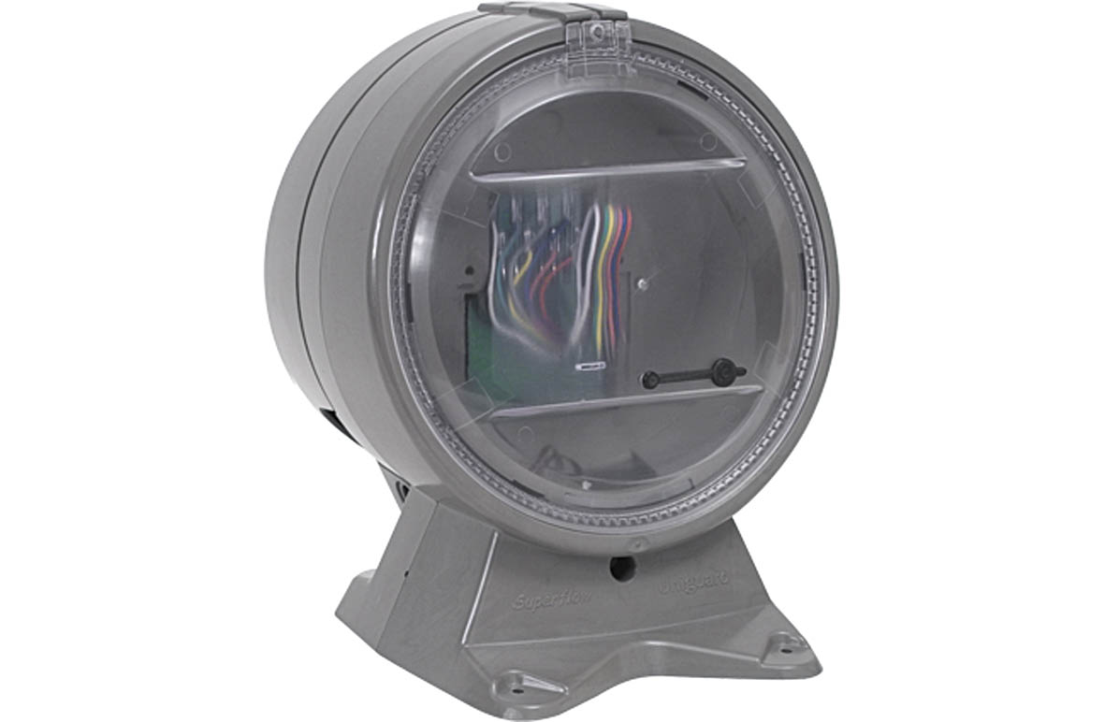 | Part Nos:  S4-34760 (Duct Sensor Housing & Base, does not include detector)

Key Features:

- 200 per loop
- S-Quad Detection used in the Duct Detector

This device shall employ a moulded plastic housing with clear viewing window and metal probes to pick up smoke in ventilation ducts. The housing shall provide a smoke entry test point and an airflow indication. Dependant on the risk and sensitivity levels required, the sensor to be fitted shall be selected from the full range of sensors available and not factory fitted.

This unit is particularly suitable for sensing smoke particles in ducting which is likely to be in large quantity and flowing fairly quickly.

The states of operation will be as described for the particular sensor.

Duct Sensor Literature

5. S-QUAD BASES
All of the above shall be compatible with the aforementioned base providing inter-changeability between sensor heads, without the requirement for switch settings

The bases for interfacing between the loop wiring and the sensor head will be manufactured by means of injection moulded ABS plastic coloured white and shall not contain any electronics. The bases are suitable for mounting on UK industry standard BESA or conduit boxes

Bases can be provided with a plastic removable dust cover for protection during site construction as well as an IP rated sealing gasket to prevent dirt and moisture from entering through from the fixing surface.
Removal of a sensor from the sensor base shall not affect the continuity of the detection loop.

All bases include the connection to provide a monitored fire or fault input from third party equipment for display and operation at the control and indication panel or in the case of remote locations, connection to a Remote LED by means of a fault monitored 2 core cable.

6. MANUAL CALL POINTS

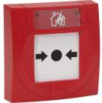 | EN54 part 11 & 17  Part Nos:  S4-34800 (Manual Call Point c/w Glass)  S4-34842 (Manual Call Point c/w Glass & Protective Cover)S4-34805 (Manual Call Point c/w Resettable Element, this element can be branded)  S4-34845 (Manual Call Point c/w Resettable Element & Protective Cover)  S4-34805 EP (Manual Call Point (IP67) c/w Resettable Element & Protective cover)

Key Features:

- 200 per loop
- Option of glass or resettable element
- Surface or Semi Flush options
- 2 integral Line Isolators
- Weather Proof Variant (IP67)

Each MCP shall contain its own microprocessor ensuring a less than 1 second response time from initiation.

All electronic devices contained within the MCP shall be sealed so as to prevent damage from hostile environment conditions: i.e. dust, up to a rating of IP32. For additional protection from environmental conditions a weatherproof version of the MCP shall be available to provide a rating of IP54.
The MCP will be available for either semi-flush or surface fixing. Semi-flush flanges shall be available in black.

The device can be tested functionally without the need to either remove the front cover and/or break the glass, using a special test key (supplied as standard). The key shall insert in a keyway concealed by a sliding cover.

Upon operation of the break glass the integral LED will flash to denote operation, this being cancelled upon the operation of a reset procedure. The system must not allow a “Fire” reset to take place until a new glass has been correctly inserted. Should a “Fire” reset be operated with a MCP still being in the operated mode, the panel will inform the user of the situation, e.g.

- “Call Point not reset properly
- Please investigate and try again”

These devices will comply fully with EN54 Part11

A keyswitch version of the MCP shall be available for use in areas where malicious action is expected t be frequent or where unauthorised activation may present additional hazard. This unit is not certified (part ref - S4-34807 - Manual Call Point c/w Keyswitch)

Manual Call Point Literature

Download CAD/BIM Symbols

7. SOUNDERS

7.1 SYSTEM SOUNDER
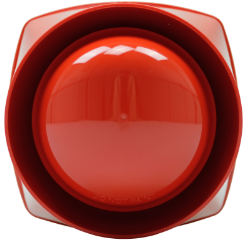 | EN54 Part 3 & Part 17  Part Nos:  S3-S-R (103db Electronic Sounder (Red)  S3-S-W (103 db Electronic Sounder (White)

Key Features:

- 200 per loop
- Red & White options
- 103 dbA @ 1 metre
- 3 Sound signals
- 2 integral Line Isolators

System sounders shall be capable of providing a minimum sound level of 103dBA ± 2 dBA @ 1 metre.

Sounder:

The sounders shall be capable of providing 3 different sound signals, which are selected/configured via the main control panel. Configuration of sounder patterns will not be carried out locally at individual sounders.

In order to meet with the requirements of BS5839 Part 1, the frequency of sound signals emitted will be as follows:

- 800Hz Low tone
- 970Hz High tone

Each sounder shall include its own microprocessor to handle loop communications and monitoring.
Each sounder will actively monitor the operation of the sounder circuit and piezzo element daily and a fault indicated at the control panel if this is found to be defective
All associated electronic components shall be sealed.

S-Cubed 103db Sounder Literature

Download CAD/BIM Symbols

7.2 VOICE ENHANCED SOUNDER
EN54 Part 3 & Part 17

Part Nos:

S3-V-R (100db Electronic Sounder with Voice Enhanced Messages Red)
S3-V-W (100db Electronic Sounder with Voice Enhanced Messages White)

Key Features:

- 125 per loop
- 103 db @ 1 metre
- 3 Sound signals
- 4 Voice Messages
- Bell tone
- 2 integral Line Isolators

Speech:

The system sounder, low profile sounder and combined sounder and visual alarm unit described previously shall be available in a 'voice enhanced' version.

The sounder unit shall incorporate a microprocessor which has up to 20 seconds of available storage space to be used for voice messages or a complex tone (for example, a bell tone in the event of alarm or supervisory condition).

As standard, the flash memory shall contain the following messages:

Alert Message: (Female Voice) | “An incident has been reported in the building, please await further instructions”
Fire Message 1: (Female Voice) | “Attention please, this is an emergency please leave the building by the nearest available exit”
Fire Message 2: (Male Voice) | “This is a Fire Alarm! Please leave the building immediately by the nearest available exit”
Test Message: (Female Voice) | “This is a test message, no action is required”

It shall be possible to have bespoke site specific message and tone options recorded and installed.
A test of the message storage device, amplifier, power supply and tone generator 'piezo' within the voice enhanced sounder shall be carried out by the fire alarm control panel daily. Should the sounder fail to produce the required tone quality of sound output, then a fault indication shall be provided at the control panel. Sounders shall be capable of being tested for the conditions described above in both the quiescent and alarm state.

Bell Tone:
In addition to the voice messages above, an 8 Inch solenoid bell recording shall be provided as a standard complex tone.
All the voice messages shall be synchronised across the detection loops by means of a regular synchronisation signal generated by the fire alarm control panel.
With the voice enhanced sounder option, it shall be possible to mix the standard sound signals, voice messages & complex tones. Up to 3 different sound signals, which are selected/configured via the main control panel, shall be employed by the fire detection system. Configuration of sounder patterns shall not be carried out locally at individual sounders.
The voice enhanced sounder option shall be available with an ingress protection rating of IP31 or IP65 and shall be available in red or white colour options.
S-Cubed Voice Enhanced Sounder Literature
Download CAD/BIM Symbols

7.3 SYSTEM SOUNDER WITH INTEGRATED VISUAL ALARM DEVICE (INCLUDING VOICE ENHANCED VARIANTS)
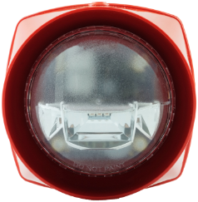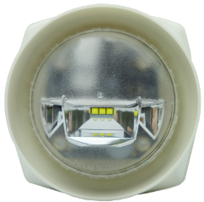 | EN54 Part 3 & Part 17 & part 23  Part Nos:  S3-S-VAD-HPW- R (103db Electronic Sounder white VAD and Red Body  S3-S-VAD-HPR- R (103db Electronic Sounder Red VAD and Red Body  S3-V-VAD-HPW- R (103db Electronic Voice Sounder white VAD and Red Body  S3-V-VAD-HPR- R (103db Electronic Voice Sounder Red VAD and Red Body

Key Features:

- Loop powered devices
- Capacity for up to 72 per loop Sounder VADs
- Red & White options
- 103 dbA @ 1 metre
- 3 Sound signals
- 2 integral Line Isolators
- Voice Sounder Variant

System sounders shall be capable of providing a minimum sound level of 103dBA ± 2 dBA @ 1 metre.

Sounder:

The sounders shall be capable of providing 3 different sound signals, which are selected/configured via the main control panel. Configuration of sounder patterns will not be carried out locally at individual sounders.

In order to meet with the requirements of BS5839 Part 1, the frequency of sound signals emitted will be as follows:

- 800Hz Low tone
- 970Hz High tone

Each sounder shall include its own microprocessor to handle loop communications and monitoring.
Each sounder will actively monitor the operation of the soubder circuit and piezzo element daily and a fault indicated at the control panel if this is found to be defective
All associated electronic components shall be sealed.

EN54-23 Visual Alarm Device

The integral VAD element shall utilise a high power red or white LEDs with variable intensity settings. LED pulsing shall be synchronised with all other loop powered audible visual units located on the fire alarm and detection system with the option to programme changes to the pulse timings (ranging from 1, 2 or 4 seconds). The VAD circuit shall be actively monitored for working operation.

Light output shall be sufficient
Activation of the VAD shall be independent of the sounder element
Light coverage of the VAD will be configurable to preserve loop power with a capacity of up to 72 devices at low power and up to 38 per loop at high power where light coverage is rated at up to 1313m³ or category W6.7-14

S-Cubed 103db Sounder Literature
Download CAD/BIM Symbols
Download Gent’s VAD Tool for iPad

Watch Gent’s EN54-23 Explainer Video

7.4 ENVIRONMENTAL PROTECTED SOUNDER WITH INTEGRATED VISUAL ALARM DEVICE (INCLUDING VOICE ENHANCED VARIANTS)

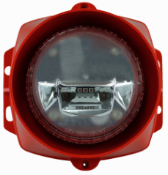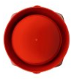 | EN54 Part 3 & Part 17 & part 23  Part Nos:  S3EP-S-R (103db Electronic Sounder white VAD and Red Body IP66  S3EP-V-VAD-HPR-R (103db Electronic Sounder Red VAD and Red Body IP66)  S3EP-V-VAD-HPW-R (103db Electronic Voice Sounder white VAD and Red Body IP66)  S3EP- VAD-HPR-R (103db Electronic Sounder Red VAD and Red Body IP66)  S3EP- VAD-HPW-R (103db Electronic Voice Sounder white VAD and Red Body IP66)

Key Features:

- Loop powered devices
- Capacity for up to 72 per loop Sounder VADs
- Red & White VADs
- Sounder output 103 dbA @ 1 metre
- Three Sound signals
- Two integral Line Isolators
- Voice Sounder Variant
- Ingress Protection Rating IP66
- System sounders shall be capable of providing a minimum sound level of 103dBA ± 2 dBA @ 1 metre.

Ingress Protection

All units in this section will be rated at IP66 suitable for surviving periods of high pressure water jets and prolonged exposure to rain.

Sounder:

The sounders shall be capable of providing three different sound signals, which are selected/configured via the main control panel. Configuration of sounder patterns will not be carried out locally at individual sounders.
In order to meet with the requirements of BS5839 Part 1, the frequency of sound signals emitted will be as follows:

• 800Hz Low tone
• 970Hz High tone

Each sounder shall include its own microprocessor to handle loop communications and monitoring.
Each sounder will actively monitor the operation of the sounder circuit and piezzo element daily and a fault indicated at the control panel if this is found to be defective
All associated electronic components shall be sealed.
EN54-23 Visual Alarm Device

The integral VAD element shall utilise a high power red or white LEDs with variable intensity settings. LED pulsing shall be synchronised with all other loop powered audible visual units located on the fire alarm and detection system with the option to programme changes to the pulse timings (ranging from 1, 2 or 4 seconds). The VAD circuit shall be actively monitored for working operation.

Activation of the VAD shall be independent of the sounder element.

Light coverage of the VAD will be configurable to preserve loop power with a capacity of up to 72 devices at low power and up to 38 per loop at High-power where light coverage is rated at up to 1313m3 or category W6.7-14.

8. HAND HELD REMOTE CONTROL UNIT

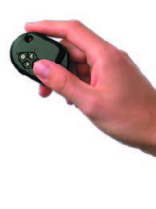 | Part Nos:  S3-Control (Handilink Remote Control for Sounders, only for commissioning purposes)
A hand held, infra red remote control shall be available for sound level adjustment on all system sounder, low profile sounder and combined sounder/visual alarm devices.
The unit shall comprise of an infra red transmitter with the ability to be operational from up to 3 metres from the alarm device.

The unit shall only be operational with the fire alarm devices when the control and indicator panel is in the 'commissioning mode'.

The unit shall switch the sounders off and on and shall also adjust the volume of the devices.
The hand held remote control unit shall be compatible with the equivalent range of conventional alarm products.

9. SOUNDER CONTROL
Loop wired sounders may be grouped or SECTORED together to provide phased or delayed evacuation procedures. All linking of sounders and output patterns shall be easily configured within the control panel software, giving flexibility of use should any of the site criteria change at a later date.

10. INTERFACE UNITS
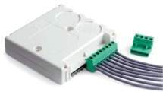 | EN54 Part 17 & 18  Part Nos:  S4-34450 (4 Channel Input/Output Interface)  Mounting Options available  S4-34490 Large plastic enclosure  S4-34491 Din Rail mounting bracket  S4-34492 Metal Enclosure

Interfaces will be directly connected to the loop, these being:

Loop powered 4 channel interface unit
Loop powered 1 Channel Input Unit/Zone Module
Loop powered 1 Channel Input/Output Interface Unit
Loop Powered 1 Channel Output Interface MV
Loop powered 1 Channel Mains Switching Interface Unit
Loop powered 4 Channel Mains Switching Interface Unit
Mains powered 4 channel interface c/w integral power supply and battery standby (2 versions)
12 NON Fire Input Unit

10.1 LOOP POWERED 4 CHANNEL INTERFACE UNIT
- 170 per loop (8 if sectored channels set up) or
- 32 per loop if used as Conventional Zone Module (with no requirement for auxiliary power
- Four input signals which can be interpreted as
  - Zone Fire (conventional Zone) input channel one only
  - Fire Input
  - Fault Input
  - Supervisory Input
  - Confirmation Input
- 4 output signals which can be individually programmed as
  - Output
  - Confirmation Output
- Any combination of inputs or output (Conventional Zone only available on Channel 1)
- NO or NC contacts (configurable)
- Contacts rated at 2A 24V DC
- 2 integral Line Isolators

For input applications, a selectable delay is available

These units will not require any form of external power supply and are fully maintained under mains power failure condition by the control panel’s standby batteries.

Loop Powered 4 Channel Interface Literature
Download CAD/BIM Symbols
Download Gent’s Interface Selector App for iOS and Android

10.2 LOOP POWERED 1 CHANNEL INPUT UNIT/ZONE MODULE

AWAITING IMAGE | EN54 Part 17 & 18  Part Nos: S4-34410  Mounting Options available  S4-34490 Large plastic enclosure  S4-34491 Din Rail mounting bracket  S4-34492 Metal Enclosure

Key Features:

- 170 per loop or
- 32 per loop if used as Conventional Zone Module (with no requirement for auxiliary power)
- Input signals which can be interpreted as
  - Zone Fire (conventional zones)
  - Fire Input
  - Fault Input
  - Supervisory Input
- 2 integral Line Isolators

For input applications, a selectable delay is available
These units will not require any form of external power supply and are fully maintained under mains power failure condition by the control panel’s standby batteries.

Single Channel (Input) Interface Literature
Download CAD/BIM Symbols
Download Gent’s Interface Selector App for iOS and Android

10.3 LOOP POWERED 1 CHANNEL INPUT/OUTPUT INTERFACE UNIT
AWAITING IMAGE | EN54 Part 17 & 18  Part Nos: S4-34420  Mounting Options available  S4-34490 Large plastic enclosure  S4-34491 Din Rail mounting bracket  S4-34492 Metal Enclosure

Key Features:
- 200 per loop
- Input signal which can be interpreted as
  - Fire Input
  - Fault Input
  - Supervisory Input
  - Confirmation Input
- Output signal can be programmed as
  - Output
  - Confirmation Output
- NO or NC contacts (configurable)
- Contacts rated at 2A 24V DC
- 2 integral Line Isolators

For input applications, a selectable is available.
These units will not require any form of external power supply and are fully maintained under mains power failure condition by the control panel’s standby batteries

Single Channel Input/Output Interface Literature
Download CAD/BIM Symbols
Download Gent’s Interface Selector App for iOS and Android

10.4 LOOP POWERED 1 CHANNEL OUTPUT INTERFACE MV
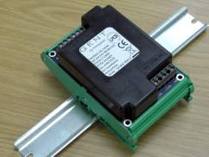 | EN54 Part 17 & 18  Part Nos:  S4-34411 (1 Channel Output Mains Switching Din Rail Mounted)  S4-34415 ( 1 Channel Output Mains Switching Metal Boxed)

Key features:

- 200 per loop
- NO or NC contacts
- Contacts rated at 13A at a nominal voltage of 230VAC/24V DC

10.5 LOOP POWERED 1 CHANNEL INPUT/OUTPUT INTERFACE MV
AWAITING IMAGE | EN54 Part 17 & 18  Part Nos:  S4-34401 (1 Channel Mains Switching Interface)

Key features:
- 200 per loop
- Input signal can be interpreted as
  - Fire Input
  - Fault Input
  - Supervisory Input
  - Confirmation Input
- Output signal can be programmed as
  - Output
  - Confirmation Output
- NO or NC contacts (configurable)
- Contacts rated at 13A at a nominal voltage of 230VAC/24V DC
- Boxed
- 2 integral Line Isolators

For input applications, a selectable delay is available
These units will not require any form of external power supply and are fully maintained under mains power failure condition by the control panel’s standby batteries.

Mains Switching Interface Literature

Download CAD/BIM Symbols
Download Gent’s Interface Selector App for iOS and Android

10.6 LOOP POWERED 4 CHANNEL INPUT/OUTPUT INTERFACE MV
AWAITING IMAGE | EN54 Part 17 & 18  Part Nos:  S4-34404 (4 Channel Mains Switching Interface)

Key features:

- 200 per loop
- andlinkInput signal can be interpreted as
  - Fire Input
  - Fault Input
  - Supervisory Input
  - Confirmation Input
- Output signal can be programmed as
  - Output
  - Confirmation Output
- NO or NC contacts (configurable)
- Contacts rated at 13A at a nominal voltage of 230VAC/24V DC
- Boxed
- 2 integral Line Isolators

For input applications, a selectable delay is available

These units will not require any form of external power supply and are fully maintained under mains power failure condition by the control panel’s standby batteries.

Mains Switching Interface Literature
Download CAD/BIM Symbols
Download Gent’s Interface Selector App for iOS and Android
10.7 MAINS POWERED INTERFACE UNITS
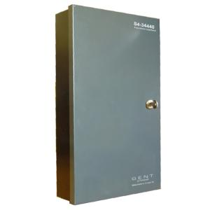 | EN54 Pts 4 & 17 & 18  Part Nos  S4-34440-02 (2 amp Mains Interface Unit c/w 2.1 AH Batteries)  S4-34440-12 (12 amp Mains Interface Unit c/w 12AH Batteries)
Key features:

- 32 per loop or 8 per loop if fully sectored
- BS7273 pt4 Cat A & B Compliance (Door Release Standard for Fail Safe Mode)
- 4 input signals which can be interpreted as
  - Zone Fire (Conventional Zones)
  - Fire Input
  - Supervisory Input
  - Confirmation Input
- 4 output signals which can be individually programmed as
  - Output Monitored
  - Output Non Monitored
  - Output LED
  - Confirmation Output
  - Drive Conventional Bells/Sounder/Beacons
- Any combination of inputs or outputs
- 230v supply required
- 2 x 2.1 AH (S4-3444-02) or 12AH (S4-3444-12) batteries for 24hr back up
- Can provide Auxiliary 12v/24v DC
- 2 integral Line Isolators

Input channels shall be capable of supporting the specified manufacturers current range of conventional detectors and manual call points, these being 24VDC operational.

These circuits will be fully monitored for open and short circuit faults providing that these devices are installed correctly and terminated with the correct end of line monitoring device.

Output channels will be capable of providing a 24V output in the event of an alarm. This may be used for driving conventional bells/relays. Providing these devices are installed correctly and terminated with an end of line monitoring device, the output will be fully monitored for open and short circuit faults. Each channel can provide 500mA in the event of an alarm condition being initiated. (1.5 or 2.5amp total load depending on model)

An auxiliary, 24VDC, 500mA, power supply will be available from the interface unit for the control of ancillary services.

Within the enclosure provision will be made for mounting up to 4 octal base relays for remote signalling along with a suitable voltage barrier.
In the event of any of the above faults occurring or a problem developing with the mains or battery supply, a suitable fault message will be displayed on the fire control panel, e.g.

- Interface Input o/c
- Mains Supply Lost
- Interface battery fault
Confirmation that loop communications between interface units and main control panel are being carried out shall be identified by means of an on-board LED, which will illuminate upon a communications breakdown. Similarly an indication will be provided to represent 230VAC is being supplied to the unit.

Mains Powered Interface Literature
Download CAD/BIM Symbols
Download Gent’s Interface Selector App for iOS and Android

Watch Gent’s BS7273-4 Explainer Video

10.8 LOOP POWERED SINGLE INPUT KEY OPERATED INTERFACE (NON FIRE)

AWAITING IMAGE | EN54 Pts 17 & 18  Part Nos:  S4-34418 complete with housing and mounting box and 2 keys

Key Features:

- 100 per loop
- 1 Non Fire Input Signals on a single channel
- Label for each input

10.9 LOOP POWERED 12 WAY NON FIRE INPUT UNIT
AWAITING IMAGE | EN54 Pts 17 & 18  Part Nos:  S4-34412 (supplied complete with S4-34410)

Key Features:

- 100 per loop
- 12 Non Fire Input Signals on a single channel
- Label for each input
- 12 Confirmation Outputs

10.10 SERIAL INTERFACE WITH HONEYWELL VOICE ALARM
The Vigilon Fire detection and control panel shall have the functionality to integrate directly with the Honeywell VA system via serial interface.
Key Features:

- Message routing to control up to 255 alarm zones
- Dual redundant link utilising parallel link with second Vigilon panel in a Vigilon network
- Full monitoring of serial connection in accordance with BS5839-8 2013
- Recovery of active alarm events in case of interruption of the serial connection

10.11 FAAST INTERFACE UNIT

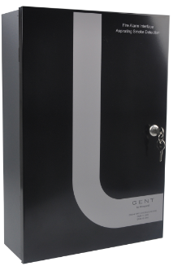 | EN54 Part 17 & 18  Part Nos:  S4-34440-ASD (Interface for FAAST Aspirating System)

Key features:

- Combined EN54-4 power supply and loop interface in a single device
- Interface Integrating Aspirating System with the Vigilon Loop
- Predefined configuration to support the complete range of FAAST ASD systems
- 100 per loop
- 2 integral Line Isolators
- Eliminates the need for separate power supply and Interfacing
- Integral Batteries for standard 24hour standby

11. WINMAG GRAPHICS

Site Monitoring Software Package Options
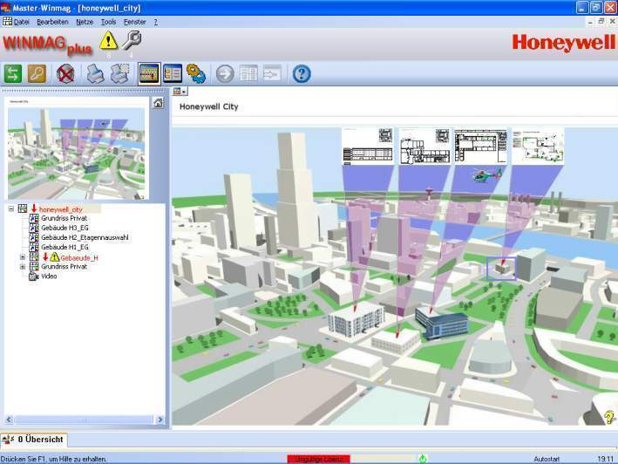

To permit WINMAG plus to run at an adequate speed your PC should fulfil the following requirements:

- PC/laptop, IBM-compatible, Dual Core or higher
- Main memory: minimum 2 GB; recommended 4 GB
- Min. 80 GB disk space
- XGA graphics board with 4 MB video memory
- Monitor with a resolution of min. 1024 x 768 pixel
- Mouse, trackball or other Windows compatible pointing device
- WINMAG plus software incl. necessary options
- Sound board with external loudspeakers (necessary for sound output)
- USB interface for dongle
- Serial interface
- Network interface card
- RS232 serial ports
- XGA graphics with 4MB video
- 17 “ Screen (1028 x 768)
- Network Adapter (for multi-station configurations)

WINMAG plus runs under the following 32- and 64-bit operating systems:
- Windows Server 2008/Server 2008 R2 (Foundation Editions not possible)
- Windows 7 (Home Editions not possible)
Your computer must be equipped with the following additional software:
- Internet Explorer Version V5.0 or higher
- When using ExtProt the Microsoft Internet Information Services (IIS) must be installed.

The monitoring system shall be available with the following Options:

- Support for up to 4 Visual Display screens
- Client/Server functionality for remote PC`s (max 6) on same Lan/Wan
- Capability for Remote access via Internet Browser
- Have OPC Client/Server capability

The Graphic drawings shall be accepted in the following formats by the system:
- Bitmap (*.bmp)
- JPEG (*.jpg)
- TIF (*.tif) and PNG (*.png)
- WindowsMetaFile (*.wmf)
- EnhancedMetaFile (*.emf)
- AutoCad 2000/2002/2004/2005 (*.dxf)
- AutoCad 2000/2002 (*.dwg)

Display of events

The visual display shall be capable of showing both Text & Graphics and with up to 12 different graphic views available on screen simultaneously.
The Text display shall provide the Time, Date, Alarm Reason, Address, Label, Auxiliary Event Information and Auxiliary Device information for any device in a Pre-Fire, Fire, Fault or Non-Fire condition.
All Alarm Reasons (Pre-Fire, Fire, Fault, Non-Fire or Disablement) shall have colour differentiation and be capable of executing different display, acknowledgement and reset routines.
The Graphics display shall give a graphical representation of the location of the device(s) or zone(s) as per the site installation, being displayed on one of a set of hierarchical building plans using different colours and icons for Pre-Fire, Fire, Fault, Non-Fire or Disablement conditions.
Active event counts shall be shown on a summary bar and each event shall be shown in an active log and saved to an historic log. The active log window shall be adjustable in size as required.
Operating modes and user access rights

The Administrator of the system shall be capable of setting up multiple users with unique access rights, toolbars and passwords.
Access rights shall be configurable for all aspects of the system including availability of menus/information and system controls, for example Silence/reset/disable.
Control Functions

The system shall allow for the configuration of up to 10 customized tools under the Tools menu, giving access to internal and external programs eg. Explorer, AutoCad etc

The system shall have manual programmes for the following:
- Disabling ranges of Sounder outputs
- Disabling ranges of Devices
- Disabling ranges of Zones
- Editing Auxiliary Text for Pre-Fire, Fire, Fault & Non-Fire events
- Global Controls including Sound Alarms, Silence Alarms, Reset and Cancel Buzzer

Graphic Functions

It shall be possible to be able to Zoom into graphic pages for increased detail.
It shall be possible to have graphics within graphics which when clicked with the mouse pointer will immediately change to that full graphic.
It shall be possible to create graphic linking from any part of a graphic page which when clicked with the mouse pointer will immediately change graphic page to that link.
It shall be possible to create links on graphic pages to custom macros and popup programmes.
It shall be possible to view the Graphic Page Hierarchy in a Tree format.
It shall be possible to move the mouse pointer over a device within the Graphics Pages and a pop up will display the Control Panel, Loop Number and Label for that device. By using a mouse click allow a pop up for Control & Information for that device dependent on access rights as follows:

- View status and Enable/Disable device
- View and Change Sensing State of device
- Find/Test Fire device
- Simulate all event types for that device
- View Label of device
- View and Modify Auxiliary Information for the device
- View Graphic Page title

System View

It shall be possible to view all of the control panels and devices connected to the system in a “tree” representation (an expandable hierarchy). It shall be possible to select devices in the tree by mouse clicking on them. Once a device is selected it shall be possible to perform the following functions:
- View status and Enable/Disable device
- View and Change Sensing State of device
- Find/Test Fire device
- Simulate all event types for that device
- View Label of device
- View Graphic Page title

Connecting the site monitoring system

It shall be possible to connect the PC to a single control panel, a network of control panels, or multiple separate networks of control panels via serial links.

The PC shall connect to a Network Node within the Fire Alarm Network which receives and displays all messages passed around the Network, a maximum of 3 PC connections per Fire Alarm Network.

A variety of possible connection methods shall be provided to allow for flexibility in design and to extend the distance between the PC and the secure point where necessary.

These shall include: RS232

The standard link between the PC and the fire alarm network shall be RS232. This shall allow a cable length of up to 15 metres between the PC and the point of connection to the fire alarm network.

Winmag Literature

Modem

Remote Systems can be interconnected using a System manufacturer approved Modem utilising 2 wire leased line connection.

N-PORT

Remote Systems can be interconnected using a System manufacturer approved TCP/IP converter utilising Ethernet connection.

BACnet Integration

The system should be capable of providing data on BACnet Life Safety Points, Life Safety Zones, Multi State Inputs/Outputs/Values, with an option for read / write, Binary Values & Life Safety Operations to enable integration with third party BMS.
This functionality shall be accessed via a BACnet Gateway Card connected by RS232 inside a Network Node and using a local Ethernet connection to customers LAN/WAN.

For more information
www.gent.co.uk
Honeywell Gent
140 Waterside Road
Hamilton Indutrial Park
Leicester LE5 1TN Vigilon Consultants Specification Guide. | 1.1 | 03/21
T: 02034091779 © 2021 Honeywell International Inc.

